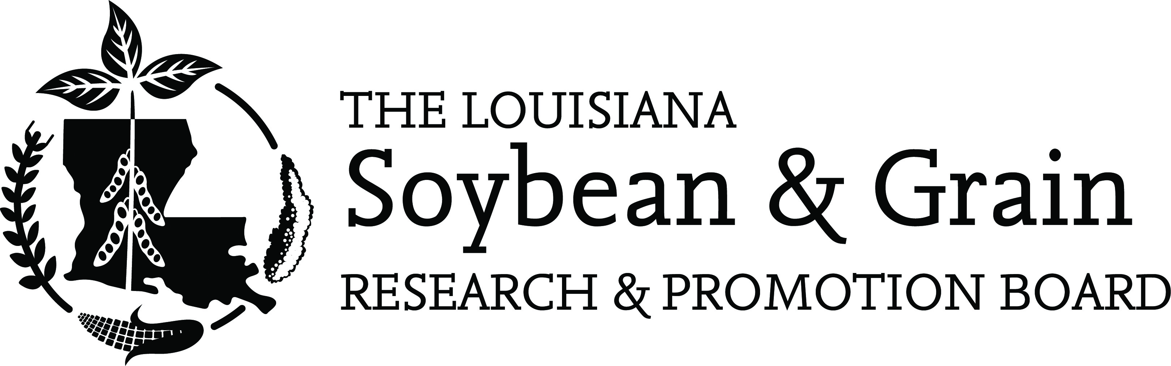

July 6, 2021

TO: Louisiana Soybean and Grain Research and Promotion Board
Charles Cannatella, Darrell Vandeven, Damian Glaser, Garrett Marsh, Scott Wiggers, Joey Boudreaux, Heath Herring, Kellon Lee, Wil Miller, Joey Olivier, Burch Pierce, Luke Sayes

FROM: Charles Cannatella, Chairman
CC: Commissioner Dr. Mike Strain, Dr. Mike Salassi, Bobby Skeen, Andy Brown

RE: Meeting Notice

The initial meeting of the newly appointed Louisiana Soybean and Grain Research and Promotion Board has been scheduled as follows:

Tuesday, July 27, 2021
4:00 p.m.
LSU AgCenter Northeast Experiment Station
Auditorium
4589 State Hwy. 605
St. Joseph, LA 71366

The purpose for our meeting is constituted in statute stating “The members of the board shall meet and organize immediately after their appointment, and shall elect a chairman, vice chairman and a secretary-treasurer from the membership of the board, whose duties shall be those customarily exercised by such officers or specifically designated by the board.” We will also provide a brief orientation to LSGRPB activities. Currently, Charles Cannatella serves as Chairman, and Scott Wiggers serves as Sec/Treasurer. The Vice-Chairman role was vacant prior to this recent appointment. We will hold elections for all positions during this meeting.

This public meeting will be held prior to the LSU AgCenter Northeast Research Station Field Day, which will begin at 5:00 pm. We encourage all board members to stay and participate. A meal will be provided as a part of the field day. Please let Andy Brown know if you cannot attend (225) 480-8842. It is important that we have a quorum to handle elections and this official business.

CC/ab

